Use Case Diagram
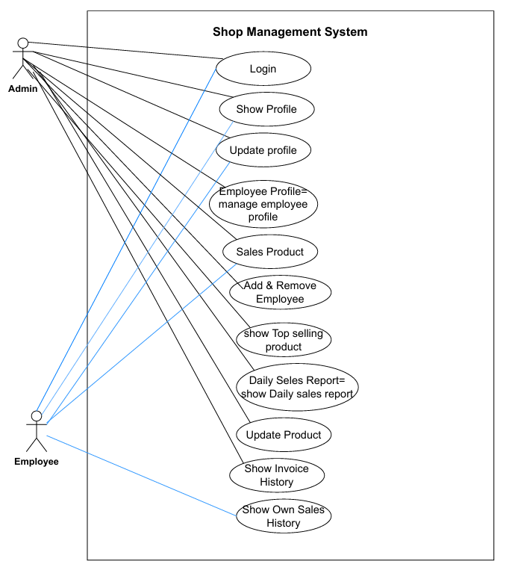

Use Case Diagram – Shop Management System
To prepare the Use Case Diagram, the system users (actors) and their roles are first identified. Their interactions with the system are represented through use cases placed inside the Shop Management System boundary. Relationships such as <> and <> are used where required.
1. Actors and Roles
Admin:
The Admin is the main user with full control over the system. The Admin manages employees, products, sales, and reports.
Employee:
The Employee works under the Admin and performs sales-related tasks with limited access.
2. System Boundary
All system functionalities are enclosed within the Shop Management System boundary. Actors remain outside and interact through defined use cases.
3. Use Cases
Common Use Cases (Admin & Employee):
- Login
- Show Profile
- Update Profile
- Sales Product
- Show Invoice History
Admin Use Cases:
- Manage Employee Profile
- Add Employee
- Remove Employee
- Update Product
- Show Top-Selling Products
- View Daily Sales Report
- Employee Use Cases:
- Show Own Sales History

4. Use Case Relationships
- Manage Employee Profile <> Add Employee
- Manage Employee Profile <> Remove Employee
- Sales Product <> Show Invoice History
- Daily Sales Report <> Show Top-Selling Products
5. Conclusion
The Use Case Diagram clearly represents interactions between Admin and Employee within the Shop Management System. It highlights access control, system functionality, and the use of include and extend relationships for mandatory and optional behaviors.

